**Exercise 1:**

* Nested list is a list within another list:



* A list can store both integers and strings inside it:

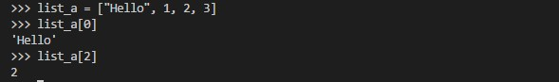

**Exercise 2: Delete an item from a list**

* Example 1:

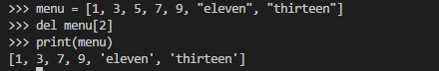

* Example 2:

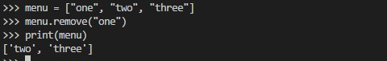

* Example 3:

